AC Graduate School Extension Project
(AC GraSE Project)

“We cannot live only for ourselves. A thousand fibers connect us with our fellow men.”
Herman Melville

Aldersgate College, as a prime institution of learning, does not only train students to become academically and professionally competent (Academic Excellence) in the fields of Arts and Letters; Natural and Physical Sciences; Business, Management and Economics; Engineering and Technology; Education; and the Health Sciences, but of equal importance is its commitment to living/existing for others (Social Relevance) by impressing norms, values and behaviors that are socially relevant to the human development needs of the majority and the less fortunate and at the same time responsive to the ideals of a democratic society. In so doing, it does, in essence, reverberate the undying words of John Wesley, the founder of Methodism, who admonishes the faithful to “(d)o all the good you can, in all the ways you can, to all the souls you can, in every place you can, at all the times you can, with all the zeal you can, as long as ever you can.”

To achieve the above goal, the Aldersgate College Graduate School, through its Aldersgate College Graduate School Student Organization (ACGSSO) conceived and set into motion Aldersgate College Graduate School Extension (AC-GraSE) Project as it seeks to work in partnership with the community and individual families to effect positive change to the world.

- BACKGROUND:

Through the years, the Aldersgate College Graduate School ACGS has been working in partnership with the different departments of Aldersgate College in the implementation of its various outreach programs. Among which is its collaboration with the College of Arts Sciences and Education (CASE) in strengthening and expanding the programs and activities of the Sinanama AC Learning Center in Baresbes, Quezon, Nueva Vizcaya by doing its share in the accomplishment of the following goals and objectives:
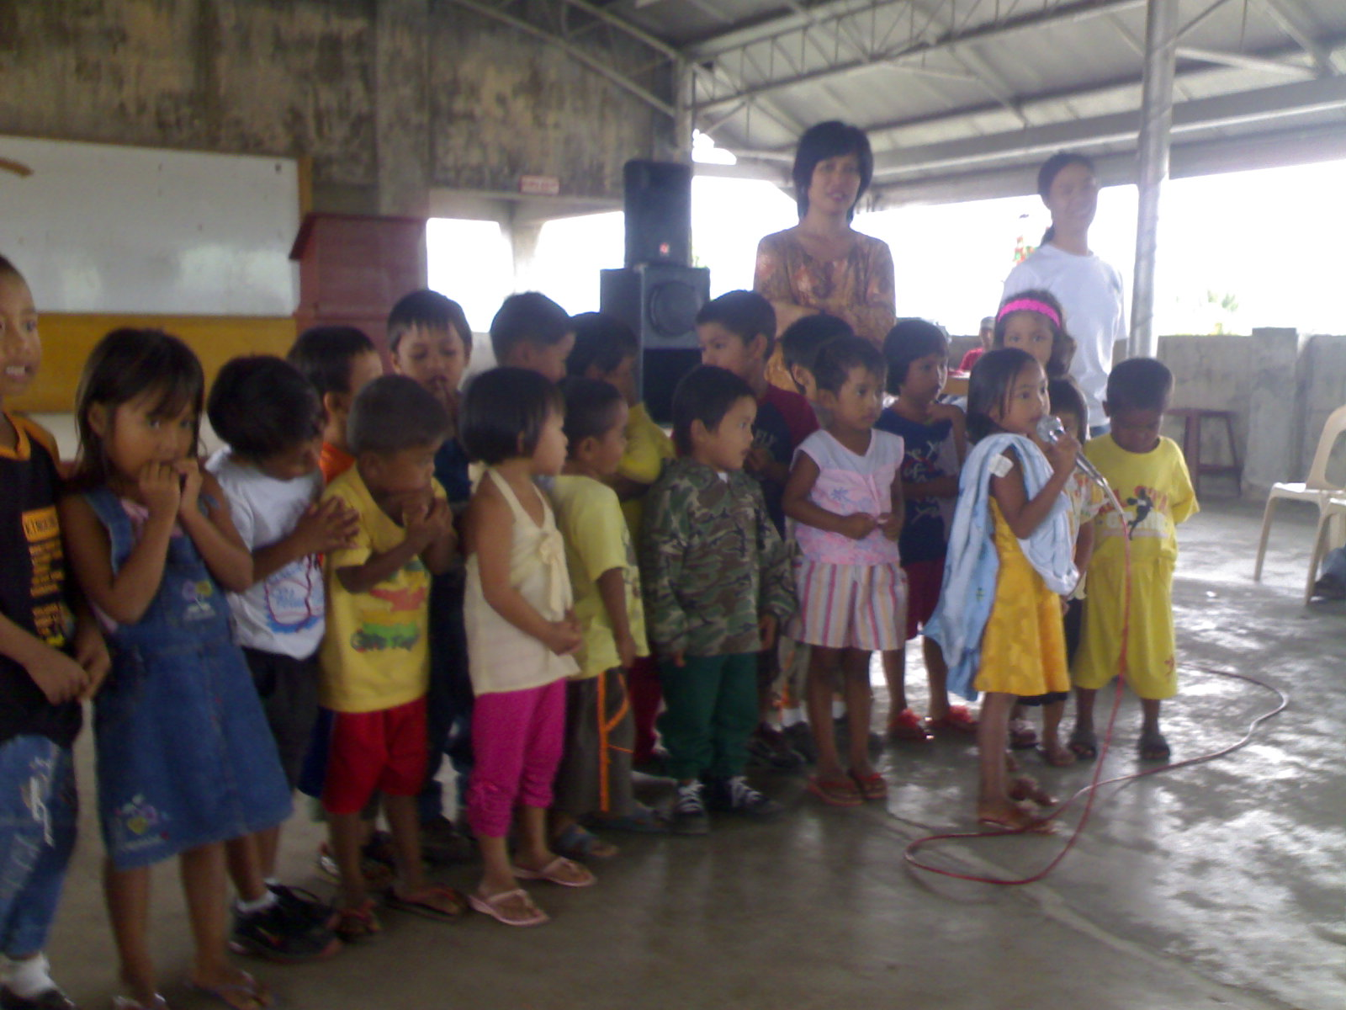
The pre-school children of Bagahabag and Curifang Daycare centers – pilot beneficiaries of AC-GraSE Project.
- Establishing early childhood development as a basic service for children ages 3-6;
- Improving the quality and efficiency of primary education;
- Enhancing literacy among pre-school children; and
- Demonstrating awareness on the role of the parents through the provision of training and seminars on good parenting, livelihood and entrepreneurship projects, and social and spiritual development.

Having the above goals and objectives attained for the folks of the beneficiary barangay and with the CASE continually doing an effective and successful supervision and implementation of the programs and actions of the said learning center, the ACGS Student Organization officers, together with their advisers decided that it is high time for the ACGS to devise its own outreach program and identify other venues for doing community involvement. Hence, the Aldersgate College Graduate School Extension Project (AC GraSE Project) was conceived.

The conception of the AC GraSE Project was an offshoot of the gift-giving activity of the ACGS students during their Christmas program held on December 20, 2008 at the Aldersgate College EZE Building Rooftop. Instead of having the usual celebration of Christ’s birth with a short program and exchanging of gifts among its members, the ACGSO officers decided to invite indigent children of Solano as special guests to said festivity and share with them the spirit of Christmas. Highlights of said program included gift-giving to the said children and treating them to a hearty meal and fun-filled games. Daton Jonathan B. Palitayan, Jr., then ACGSO Vice President, coordinated the said program with the Municipal Social Welfare and Development Office (MSWDO) of Solano, headed by Mrs. Lyn F. Lapitan, Social Welfare Officer III. MSWDO endorsed two daycare centers, that of barangays Bagahabag and Curifang both in Solano, as beneficiaries of the said activity. The workers in the said daycare centers are Mrs. Angelita R. Tuscano and Mrs. Rosalia G. Aleste respectively.

During the said GS Christmas program, Dr. Junifen F. Gauuan, Aldersgate College President, gave his special yuletide message where he signified the readiness of AC to help the said two daycare centers in effectively educating their children by providing the teachers of said centers materials from AC’s Learning Through Play (LTP) Program – a parent-child education through play program which is an international project of the Hincks-Dellcrest Centre, a center for mental health service for infants, children, youth and their families, based in 1645 Shaeppard Avenue, West, Downsview, Ontario, Canada. Taking cue from Dr. Gauuan’s speech, ACGSO officers resolved to follow through the AC president’s pledge to the daycare centers of barangays Bagahabag and Curifang by organizing their first outreach project adopting the aforementioned LTP program and the two aforementioned barangays being the project’s first beneficiaries.

Mr. Palitayan floated the above idea to Dr. Elizabeth R. Pascual, Dean of the Graduate School of Education, who advised him to coordinate and further discuss the matter with Mrs. Prescilla Esperanza A. Soriano, Director of the AC Integrated Child Development Center (ICDC) and concurrently AC’s Senior Executive Assistant for Education (SExAE). Being the ICDC director, Mrs. Soriano was tasked by the AC president to oversee the implementation of LTP in the Philippines. She was trained as a Master LTP Trainer by Azucena “Suzie” Dulay Kurz, a Filipino Canadian nurse who is the liaison officer to the Philippines for Hincks-Dellcrest Centre and responsible in introducing said program to the country. When Mr. Palitayan put forward said project to Mrs. Soriano, she readily accepted the proposal and agreed to extend a hand in the realization of ACGSO’s vision of putting up a functional and productive social oriented and community based project.

On January 24, 2009, a meeting was held by the GS faculty, students and OIC Dean to discuss, among others, what LTP is. Mrs. Soriano presented and discussed the said program and agreed to train trainers among the GS students so as to ensure its successful implementation by the AC GraSe Project project management.

AC-GraSE Project is now at its second year of effectively implementing its programs and activities with Mr. Daton Jonathan B. Palitayan, Jr. as the Project Coordinator.

To date, AC-GraSE Project has completed LTP Basic Orientation Seminar to 14 of the 25 Day Care Centers in the different barangays of Solano. Furtheremore, LTP Trainers’ Course has been conducted for all Day Care Workers of Solano.

II. GOALS AND OBJECTIVES:
The LTP Program’s objectives being complementary with the thrust of the previous outreach program of ACGS, AC GraSE Project has seamed them together. With its primary aim of fully integrating the school back to the community, AC GraSE Project will address the following objectives:
- Provide creative and innovative learning opportunities on early childhood development and responsive parenting for parents, child-caregivers, community health workers, and other individuals or group tasked on looking after the welfare of a child;
- Develop awareness of parents and other adults on the importance of early stimulation to infants and young children through play activities;
- Improve the parenting techniques of parents, particularly of 0-6 year-old children;
- Help parents understand the importance they can play in their child’s life from birth, onwards;
- Improve the quality and efficiency of primary education;
- Enhance literacy among pre-school children; and
- Demonstrate awareness on the role of the parents through the provision of training and seminars on good parenting, livelihood and entrepreneurship projects, and social and spiritual development.

III. PROGRAM BENEFICIARIES:

Barangays Bagahabag & Curifang, both in Solano, Nueva Vizcaya |  | Program Implementors  Aldersgate College Graduate School
Clientele: | Children ages 0-6 | Contact Persons
 | Parents/Guardians | Dr. Elizabeth R. Pascual &  Dr. Leopoldo A. Valdez  Program Directors
 | Daycare and Community Health Workers
 | Community Leaders & Other community | Mr. Jonathan B. Palitayan, Jr.  Extension Coordinator
 | members

IV. PROGRAM COMPONENTS:
- LTP BASIC ORIENTATION SEMINAR
(Parent groups, i.e. PTCA; neighborhood or barangay associations, yayas, grandparents, etc.)
- PARENTS’ COURSE (Basic Orientation Seminar Level 2)
- TRAINERS’ COURSE - Equivalent to a 1-unit course in the college of education (Teachers, health workers, education and nursing students, day care workers, parent-leaders)
- Health and Allied Services for Children
  - Feeding Program
  - Operation Timbang at Taas (OPT)
  - Immunization
  - Send a Child to School Program
- Parent’s Empowerment - Training on Capability Building and Entrepreneurship

V. STRATEGIES:
As the community’s most fragile members of the society, children are to be protected and given all the care they need for them to grow up to become productive members of the society. Their early childhood, as the most critical stage of their development, must be propped up by necessary development inputs aimed at maximizing their capacities for psycho-social and intellectual development. It is to this thrust that the following strategies are developed:

- Training and empowering parents, caregivers, health professionals and other stakeholders on LTP methods and techniques.
In view of a recent research finding which suggests that 75% of human brain development comes after birth, and that humans have brains that are dependent on environment input, there is a growing need to provide programs that will facilitate brain growth. Though brain development starts in the womb, the early years of life have a huge impact on how the brain will grow and absorb information. Babies are born with the need for human contact and stimulation. At birth, a baby’s brain has about 100 billion brain cells, called neurons, which need to connect to other neurons, to form a network of connections and pathways which are essential in order to think, feel or move. These connections, “called brain wiring” are formed as the child uses his senses, relates to, and has experiences with his world and the people in it. If this networking breaks or lapses, then the pattern is lost and there may be delays or uneven development.

Making individuals tasked of providing care to a child aware of this information will help them understand the importance they can play in the child’s life from birth.

- Integration of health, nutrition and other allied services.
To ensure the child’s holistic development, the project shall incorporate the provision of Health Allied Services. Thus, feeding program, immunization, OPT and other health related services shall be integrated into the project using an inter-agency but community based approach. To achieve such end, the participation of local officials and community leaders shall be actively sought.

- Equipping the parents with the knowledge on livelihood projects and entrepreneurship.
Recognizing that the child’s immediate network of support consist of his family, the project shall stress the critical and indispensable role exercised by parents to provide all the support for the child’s formative years. Trainings on capability building and entrepreneurship for parents guarantee that they will be able to provide sustainable assistance to the child under their care.

- Strengthening the partnership between school, home, the community and local government.
Essential to the attainment of the project’s goal and objectives is its closer partnership with the family and the community. The full involvement of parents shall be solicited to ensure that their children maximize the benefits derived from home, school, and community learning experiences.

Parents, particularly the mothers shall not only reinforce learning at home but shall take an active part in the management of the education program.

Local Government Units (LGU) and community organizations shall play more substantive roles in the implementation of the education program. Furthermore, they shall also be tapped in the planning, monitoring and evaluation of the said project.

VI. PROJECT MANAGEMENT:

- Structure and Personnel
- Program Directors – Dr. Elizabeth R. Pascual – Dean, Graduate School of Education
Dr. Leopoldo A. Valdez – Dean, Graduate School of Management
- Coordinator – Daton Jonathan B. Palitayan, Jr.
- Graduate Schools
  - Master of Arts in English (MAE)
  - Master of Arts in Educational Management (MAEM)
  - Master in Public Administration (MPA)
  - Master in Business Administration (MBA)

- Consultants:
- Dr. Junifen F. Gauuan – AC President
- Mrs. Prescilla Esperanza A. Soriano – Senior Executive Assistant for Education
- Mrs. Carolyn A. Amaranto – Senior Executive Assistant for Finance and Administration

